SHAWN STANFORD’S GRAND CANYON BACKPACKING ADVENTURES

March 17-21, 2007: Revisited South Kaibab, Tonto, Grandview

For a report on this route that I completed as my first solo backpacking adventure, see my April 2006 account. I completed the trek in three days at that time, but my son, Jordan, was unable to trek with me on that trip. I liked the route so much that I wanted to tackle it with him at a little slower pace. We obtained a permit for this originally planned 6-day trip in November 2006 and followed our usual preparations: tracking weather reports and forecasts, reading others’ backpacking reports, updating our gear, and planning our food rations. The forecast projected mostly sunny skies and pleasant temperatures for our entire trip, with a decrease in high and low temperatures about 4 degrees each day. We also faced about a 20 percent chance of rain on the afternoon and evening of our 3rd day and about a 10 percent chance on our 4th day, the hike out. Forecasts are not always perfect, of course, so it is always important to be prepared for drastic weather changes in the Canyon. It was nice to know starting out, however, that we would likely have decent weather for most, if not all, of the trip. Many others, including me, have written reports about this route, so in this report I will not likely offer many trail observations that have not already been covered. I will only report on what seems to be unique about this particular trip.

Day 1:

We drove to the South Rim from Phoenix in the afternoon and visited the Backcountry Office. I had been corresponding with another hiker for a couple months before the trip, and we tried to change our permit so that we could hook up with him and his group on his route. It did not work out, however, so we kept our permit and were encouraged by the rangers that we would find water at Lonetree Creek, which was our first destination for inside the Cremation usage area. Our permit was actually for 6 days: 1 day to the Cremation usage area, where we planned to reach Lonetree Canyon, and then 2 nights there; the 3rd day to the Grapevine usage area, where we planned to reach Grapevine Creek, and then 1 night there; the 4th day to the Cottonwood Creek usage area and then 2 nights there; and the 6th day out via the Grandview Trail. We had to shorten it to 4 days, though, because of an extracurricular commitment of Jordan’s; so we decided to forego the first and last days allowed by the permit and complete the trek in 4 days.

We spent the first night at Mather campground on the South Rim but slept poorly. A large group of campers a few campsites over was up until about 12:30 a.m., carrying on loudly despite the campground rules that quiet time should begin at 10:00 p.m. After about a half-hour of quiet, they apparently re-charged their batteries and began cutting up again about 1:00 a.m. for another hour or so. I felt like walking over and asking them to shut-up, and I probably should have but did not. It was one of those situations where I was too lazy to crawl out of my cozy sleeping bag to start a confrontation that I was not convinced I wanted to finish. I am amazed how at public campgrounds people can be so stupid and self-centered that they are completely ignorant of others around them that might be trying to sleep. Having backpacked to and camped in quiet settings where the only noises I have to put up with are the sounds of the wild and my own snoring, I would rather do that than camp in public campgrounds any time.

Day 2:

Both of us felt like we barely slept when we woke up at 4:00 a.m. to prepare for our long trek to Lonetree Creek. We made good preparation time, ate a good breakfast of cereal and granola bars, parked our car at the Village Store, and caught the South Kaibab-Trail shuttle about 5:30 a.m. It was still dark when we arrived at the trailhead at 5:45 a.m., and by 6:00 a.m. we started our trek down. Only one other party of about 4 trekkers was at the trailhead, and we started down a few minutes before them. It was the quietest departure from that starting point I have experienced. We started down the trail with our headlamps on, and within 15 minutes or so we did not have to use them any longer.

The weather was beautiful starting out: about 45 degrees, clear and calm skies, and no threat of nasty precipitation. In fact, by the time we reached Cedar Ridge the temperature had already risen to about 55 degrees and we were already getting too warm. We shed some clothing and started our jaunt to Skeleton Point after about a 20-minute break. When we reached Skeleton Point, we shed more clothes as the temperature had risen to about 60 degrees. We took a 10-minute re-charge break and then sauntered down the Redwall portion of the trail. This was already a couple hours after we had started our hike, and we finally ran into a few hikers heading up to the top. It took us another hour or so to reach the restrooms located at the Tonto Trail junction just prior to the Tipoff.

We took another break at the Tonto Trail junction. This is about the fifth time I have hiked down the South Kaibab Trail for various trips, and for whatever reason my legs are always more worn out than I want them to be at this point of the trip. The South Kaibab Trail is not very difficult to follow to the Tonto Trail junction, but perhaps my battle with arthritic knees and ankles has made it more of a challenge than for the average trekker. At this point, I began feeling those aches and pains in my joints. I took a couple of Ibuprofen to help offset the swelling for our long haul over to Lonetree Creek. We took about 20-minute break and then headed off eastward on the Tonto Trail.

This portion of the Tonto Trail, as Bob and others have noted, is a long and lonely one. After turning northeastward and north for about a mile and then bending around to a southerly direction, the trail begins its meander through several drainages that have to be more or less crossed rather than by-passed. I remember this portion from my April 2006 solo hike, so I warned Jordan that it would not be fun crossing two rather deep drainages within about a quarter mile in western portion of Cremation Canyon. We first took a 10-minute or so break under the overhang that sports a nice campsite but has no water, that many others have noted in their reports, before heading down the trail toward the first of the nasty drainages. By the time we descended and ascended to the other side, we were both a little worn out. The footing going up and eastward on that portion of the trail is quite steep and loose. It is probably only a couple hundred feet of a descent and then a sharp ascent to the other side, but the challenge of not sliding downward for each step forward can be taxing. We were quite parched when we were back on the Tonto Platform, even though we had been sipping water regularly through our Camelback bladders. We had been looking directly into the sun for about 1 and ½ hour, and the temperature had risen to about 85 degrees. The air was still very pleasant, but no doubt the sun in our faces had begun to take its toll.
In the bottom of the second nasty drainage we rested for about 15 minutes in the shade, for we knew we would have little, if any shade, the rest of the route to Lonetree Creek. That second ascent up is not brutal as the first one a quarter or so mile earlier, but it is still a climb that feels good to conquer by the time the Platform is reached again.

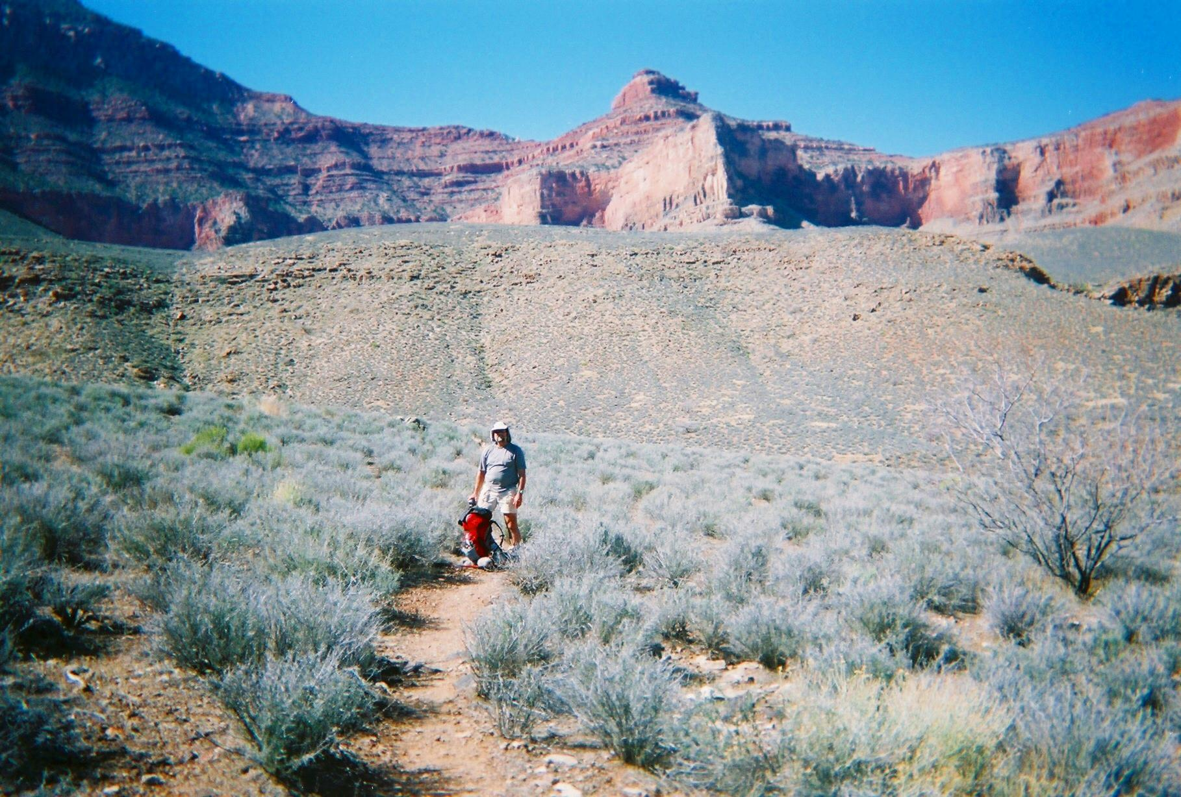
Tonto Trail in Cremation Canyon with Cedar Ridge in the background

Strangely enough, I think both us of began to feel rejuvenated once we got back to the top after crossing the second steep drainage. It was about 11:15 am, and I told Jordan that we had maybe only a couple hours more to go. When we came to the widest drainage of Cremation Canyon, on the east side, we could see the trail on the other side and were encouraged that once we rounded the plateau on that side that we might have only an hour or so more to go. Our pace moved steadily and we really began to anticipate our arrival with a renewed passion. We talked on and off as we soaked up the beautiful weather and surroundings, and about 12:00 p.m. we took another break behind a huge boulder that offered some temporary shade.

Seeing the head of Lonetree Creek from about ½ to 1 mile off is a victory on this route. We noticed it about a little after our final break, and from a distance we could see the greenery and flowing water of the creek. The sight of water always refreshes me in the Canyon desert; it encourages me that we are going to be okay. This final stretch goes in and around several drainages, so it takes a longer than might be first anticipated to reach the place where the trail crosses the creek close to several campsites. We reached the campsites about 12:40 p.m., which is nearly 1 and ½ hour faster than it took me to reach Lonetree Creek in April 2006. Not that we were racing this time, for we certainly were not; but I think we timed our rest stops more successfully than I had on this route a year earlier, and we had managed our water intake well throughout the trek. The temperature according to my watch gauge read about 94 degrees—that is quite warm for this time of year, and although we were definitely warm we were not overly heated. When I had tried to assess what our temperatures would be at this level prior to the trip, by checking the National Weather Service Website, I had expected that we might be facing about an 86-degree day that afternoon.

Interestingly, we encountered a couple of day-hikers who had been resting and waiting to finish their hike back out the direction we had come from. They looked to be in good shape but also appeared to be worn out. We asked them how they were doing, and they informed us that a day earlier they had attempted to complete the entire South-Kaibab-to-Grandview route in a single day and could not find their way of the Cottonwood Creek area to the Grandview Trail. They turned around and backtracked all the way to Lonetree Creek, the way they knew they could get out, and reached it about midnight, according to their story. They spent the night at Lonetree, and fortunately were able to keep each other warm in only mid-50 degree temperatures, but they appeared to be rather glad that we were there. They were down to their last few bites of dried fruits, so we offered them some food since we had extra and at first they turned it down. About a half-hour later, however, they accepted our offer as we finished setting up camp and we donated a package of Top Ramen and a bagel to each of them. That seemed to help lift their spirits; they were very grateful and then headed back out the trail about 2:00 p.m. It was a very concrete reminder to us how critically important it is to be prepared for the unexpected when hiking the Canyon trails. Trying to negotiate a nearly 30-mile hike in a day in the Canyon seems to me to be ludicrous, regardless of what kind of shape one is in. This route is not an easy route by any means; the constant ups and downs, ins and outs, and exposed trail sections would turn a single-day hike into a nightmare. It sounded to me like they experienced somewhat of a nightmare, and by God’s grace we were there to help re-fuel them.

We had a very pleasant afternoon and night at Lonetree. As the sun descended the temperatures dropped, of course, and by the time we were in the shadows about 4:00 p.m. we were basking in our absolutely gorgeous setting. Another couple had arrived from the same route we had taken and set up camp about 3:30 p.m., and we exchanged a few pleasant words later about the route to come. I gave them what little information I knew from my April 2006 trek on the same route, and they were very grateful. The creek was flowing steadily and provided several small pools for cooling the feet and re-charging the water supply. I even stripped bare a couple hundred yards downstream and sat in a pool that flooded my stiffening body with new life. The wind kicked up to some 10 to 15 mile-per-hour gusts for about an hour around 5:30 p.m., which seems to be normal for the Canyon. We were serenaded to sleep by a huge chorus of frogs setting up residence up and down the creek; they intermittently played their tunes for about a half-an-hour at a time with half-hour rests throughout the entire night.

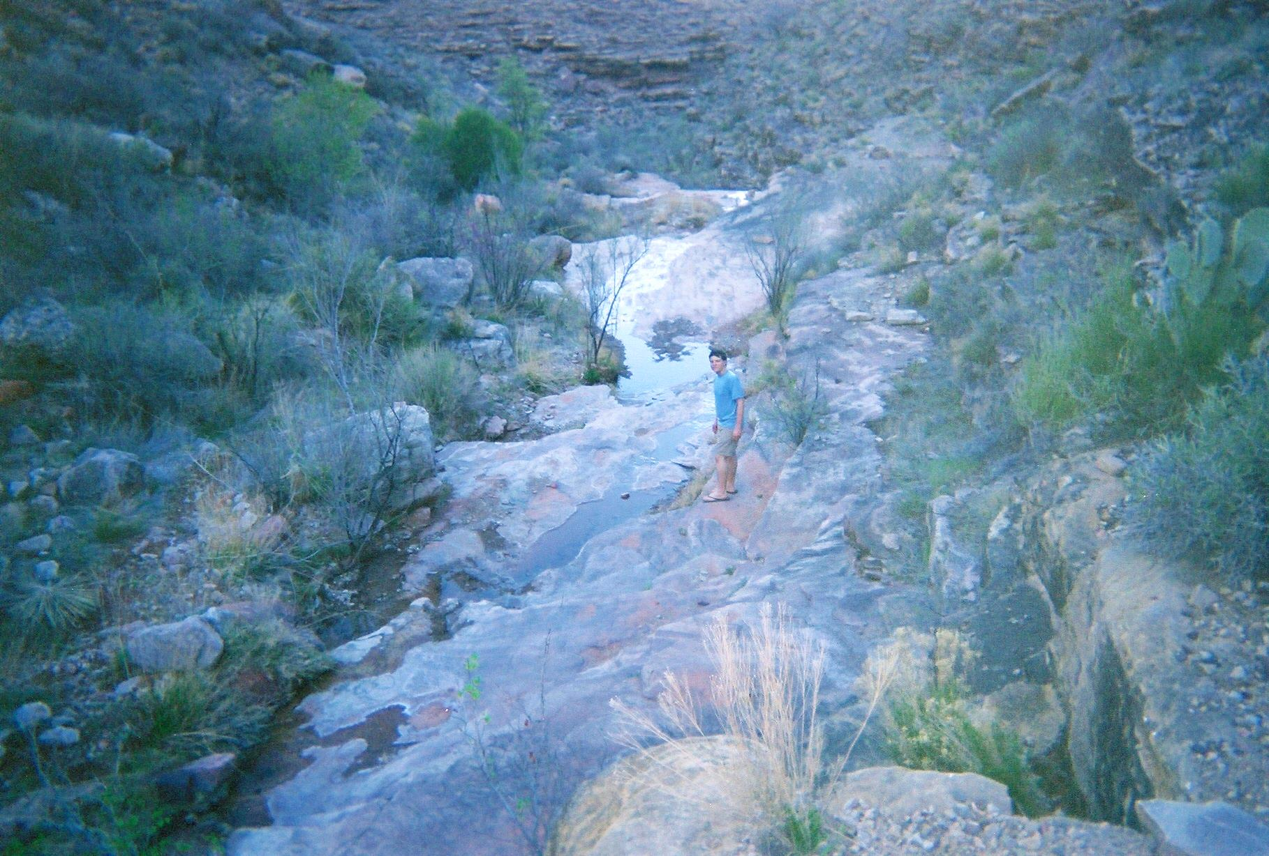
Dusk at Lonetree Creek

Day 3:

I woke up about 4:30 a.m. and let Jordan sleep another half-hour or so while I began gathering gear for our morning hike over to Grapevine Canyon. He pulled out of his sleeping bag when he heard me banging around and eagerly climbed out of it. I am blessed to have such a willing friend and backpacking companion. Ever since we started backpacking in the spring of 1998, he has eagerly embraced each and every day on the trail and has never had a motivation problem for each day’s trek. When he was much younger it was much more of challenge for me because I had to carry much of his gear besides my own, and I had to set up and tear down camp almost all by myself. Through much trial and error and as he has grown into a fantastic young man, he now carries his own load comfortably, and he contributes helpfully in every aspect of every trip. In view of how warm the Tonto Trail was the day before, we wanted to start early towards Grapevine so that we would could reach the campsite early and avoid getting baked in the middle of the day. We ate a Mountainhouse scrambled-egg meal and headed-off by about 6:30 a.m. It was sunny, clear, and calm again, with the temperature about 55 degrees as we climbed out of the Lonetree drainage and moseyed along the Tonto Trail generally northward.

This day offered no unusual adventures. The weather was fantastic and the trail was easy-going. I brought a camcorder with us on this trip so that I could take video shots in addition to the snapshots we would take with our camera. I had wanted to take videos for a long time but never before wanted to cram it into my pack. The one I brought for this trip was palm-sized and relatively lightweight. I had taken couple of minutes worth of video on our trek to Lonetree, and this day I wanted to take some Tonto Trail footage as we walked it to our next destination. I actually shot a few minutes’ worth as we walked along the trail, and after I tired then Jordan also shot a few minutes. Little had I realized, however, until I paid attention to the battery-power level, that somehow the power switch must have flipped on while the camera was in my pack. By the time we obtained this trail footage, we might have had another 10 to 15 minutes left of power before the battery ran out. My daughter has warned me about this and I thought I had taken the precaution to wrap the camcorder tightly in a bag so that it would not happen, but it still happened. Consequently, I was disappointed that I would not be able to take as much video as I had hoped. We had taken maybe 10 minutes of video to that point, and I had planned to take about an hour’s worth in total.

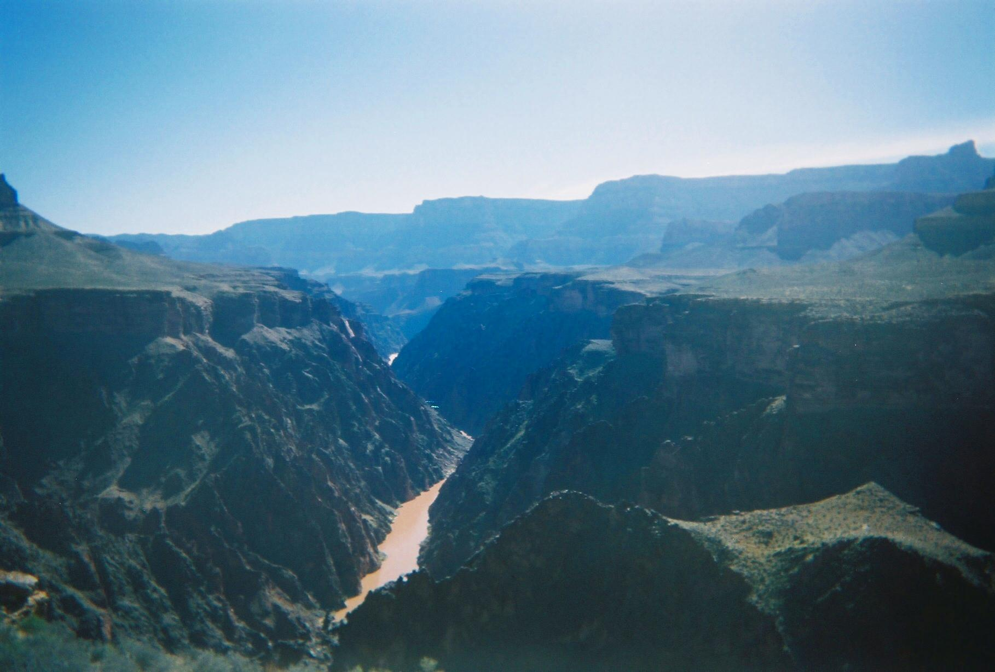
Looking east at the Colorado River from the Tonto Trail on the way to Grapevine Creek

The trail was quiet. I had warned Jordan that the trail might fade in and out as we rounded the plateau going into Boulder Creek. In April 2006 I lost the trail for a stretch in that section, and this time I wanted to see if I could figure out why. Jordan typically leads the way as we hike, so he paid super-close attention to the trail this time. He did a fantastic job at figuring out some of the tricky parts where the trail crosses small water paths and seems to branch out in various possibilities, and with his help we pretty much figured out where I had gone wrong previously. That place is where there is a line of stones that seem to cross the trail about a mile from Boulder Creek; one of the stones is about the size of a regular-sized house brick. Actually, the stones mark that the trail turns abruptly to the right and begins to head in a meandering direction more generally south than the east-southeast direction we were going. On my April 2006 trek, I remember crossing that line of stones and kept going, thinking it was rather strange but continuing any way. At that time I continued for a couple more hundred yards until I realized I was strangely getting closer to the edge of the plateau and should head back to find the trail. This time Jordan noticed the right-hand turn and saw the cairn that pointed us in the correct direction. For about a quarter of a mile the trail snakes in and out and along water channels, and it is easy to wander off in directions that look like the trail but are not. The key seems to be to pay close attention to the cairns that mark the trail land the footprints that confirm its travel. As long as Boulder Creek is kept in the general view, it is not that difficult to keep going in the right direction in the event the trail is lost. The trail generally goes around the drainage tips, so if you find yourself dipping down into them steeply only to have to climb out equally steeply then you can be assured you are too low and not following the trail.

We rested for about 15 minutes in Boulder Creek and then moved on eagerly. After about 30 minutes, we looked northwest back across Boulder Canyon and noticed the couple that showed up in Lonetree a few hours after we arrived were about an hour behind us. In about 15 more minutes, we met a father-son pair going to where we had departed and they were glad to hear that water was running in Lonetree. They assured us that water was also available in the east arm of Grapevine. In another hour or so we began the final, seemingly endless west-side leg that enters Grapevine. Jordan informed me as he led the way that he was a little uneasy about the closeness of the trail to the edge, but the closer we approached the head of Grapevine the more secure he felt as the trail began its repetitive winding around the many side drainages that lined the trail to get there. The temperature warmed up to about 75 degrees by 10:30 a.m., and when we reached the campsites at Grapevine the temperature was about 85 degrees.

Water was again a welcome site in Grapevine. We were surprised that even though Grapevine is marked as a perennial water source that its flow was actually lighter than the stream we met in Lonetree. At the end of April 2006, Grapevine was definitely flowing stronger than it was this time, and Lonetree was also flowing about the same level we had encountered yesterday. We set up camp under a big cottonwood tree that is practically right on the trail as it crosses the drainage, rigging a tarp with my trekking poles and the tree. That was our only shelter for the rest of the afternoon, and we took it down when the sun lowered enough behind the western wall that we were able to live comfortably in the wall’s shade. About 1 and ½ hour after we arrived, the couple that was behind us showed up and set up camp. About 3:00 p.m., a group of 6 college students coming from the Cottonwood Creek side of the drainage showed up in singles and pairs over about a 15-minute time-frame. That group was on the 2nd day of a 7-day trek from the Grandview Trail to Hermit’s Rest. They were an energetic and jovial group, and 2 of them hiked downstream after arriving and did not return until about 6:00 p.m., only after the rest of the group went downstream to look for them about 5:00 p.m. and returned without them. The night was so gorgeous that Jordan and I slept uncovered in our sleeping bags, at first fighting spiders crawling around as we bedded down but eventually not seeing any after we shut of the headlamps. We noticed that the college group had bedded down open-air style also, but the couple that had followed was sacked out in their dome tent. As in Lonetree, we got to listen to the hundreds of frogs that croaked on and off during the night. The skies sported an absolutely stunning display of stars that kept me entertained for quite awhile as I had some difficulty falling asleep.

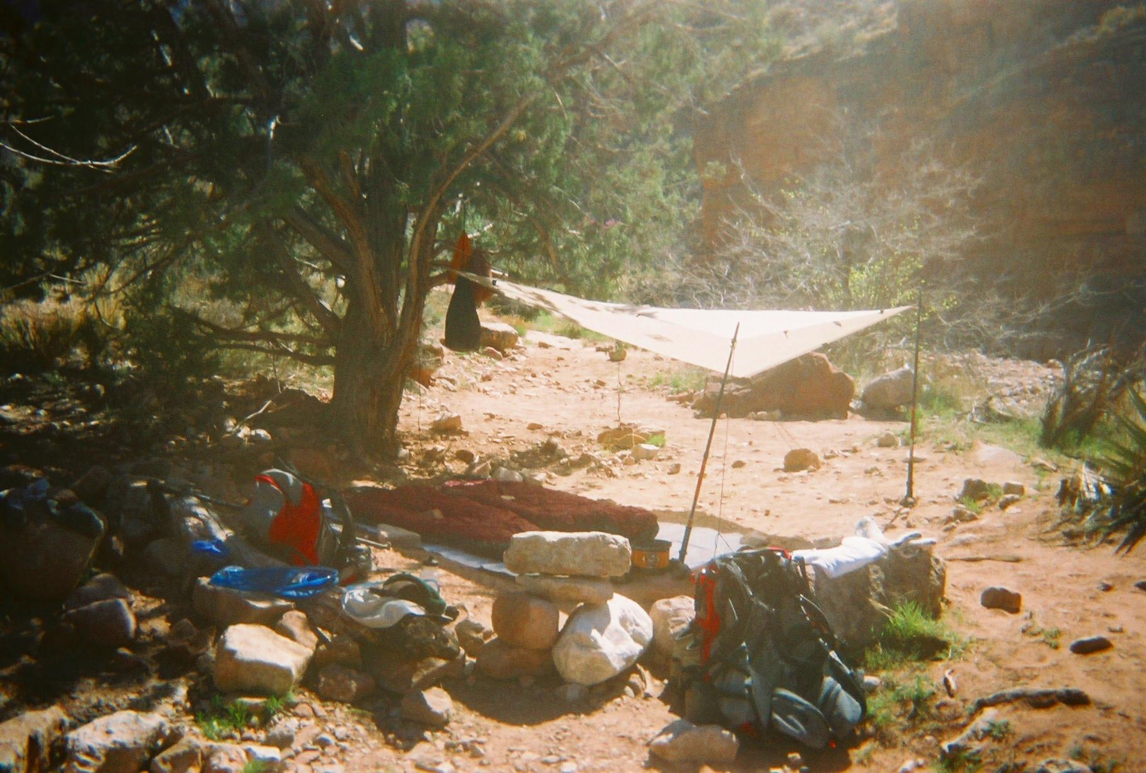
Campsite at Grapevine Creek

Day 4:

We were out of camp about 7:00 a.m. and winding our way along the east side of Grapevine for at least a couple of hours. Leading the way as usual, Jordan spoke his uneasiness about the trail being so close to the edge. I could relate. This stretch offers marvelous views that I have found are paralleled nowhere else in the Canyon. The trail seems dangerously close to the edge at points, and I find I have to keep focused directly in front of me so as not to become a little intimidated at the sheer drop-off. Entering the spring-fed oasis about a mile north of Grapevine is actually a nice relief since the trail passes through a broad, rather flat rocky area stretched off the edge of the drainage.

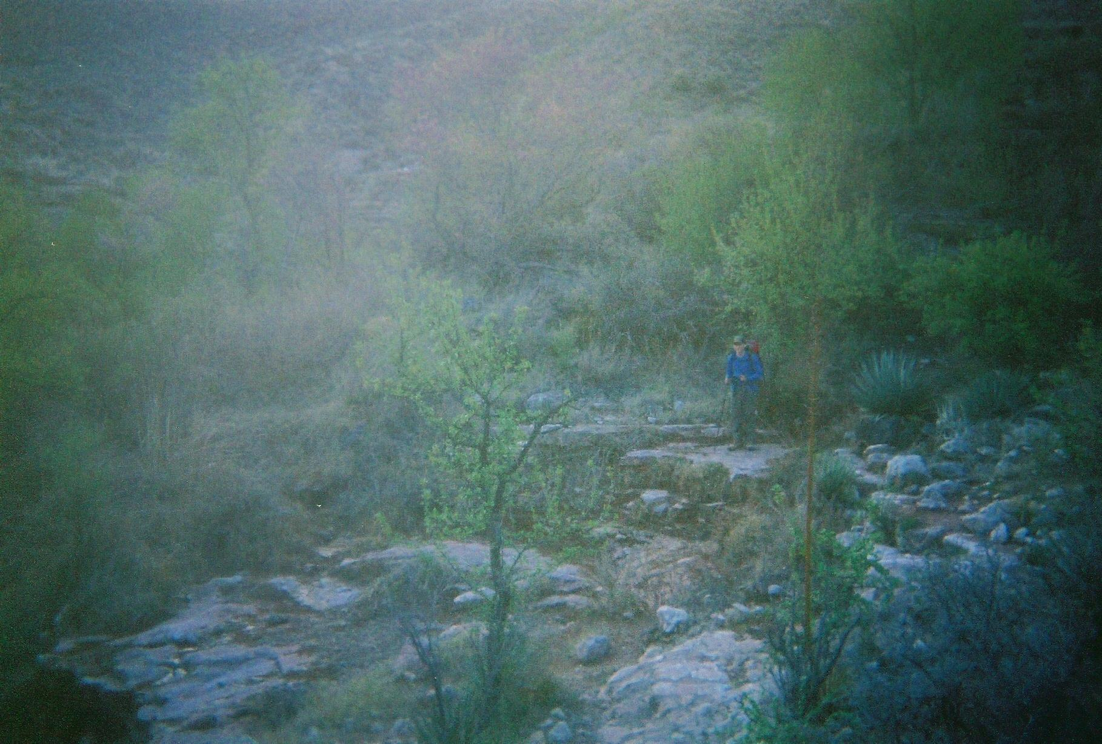
Crossing the Oasis on the east side of Grapevine Canyon

The trek over to our next destination was pretty uneventful. The trail is not difficult, overall, and it took us about 3 and ½ hours to reach the campsites. The only frustration I found this time on this stretch of trail is the length of time it takes to reach the beautiful, almost sparkling, postcard-like Cottonwood Creek setting that is visible from about 1 and ½ miles away, as the crow flies, rounding the final plateau before heading generally south toward the drainage. It looks like it will take no more than about 20 minutes to get there, but it took us about 1 hour and 15 minutes because of the constant ins and outs of side drainages and the trek around the northwestern arm of Cottonwood.

By the time we reached the vacant campsites of Cottonwood Creek’s north-south draw, the temperature had risen to about 70 degrees at 10:30 a.m. The clouds and breezes has moved in and, as on cue by the weather forecast we had read a few days earlier, by early afternoon we looked like we might get some rain. We set up camp under the big cottonwood tree that is right next to where the Tonto Trail crosses the drainage and heads around a northerly direction around Horseshoe Mesa.
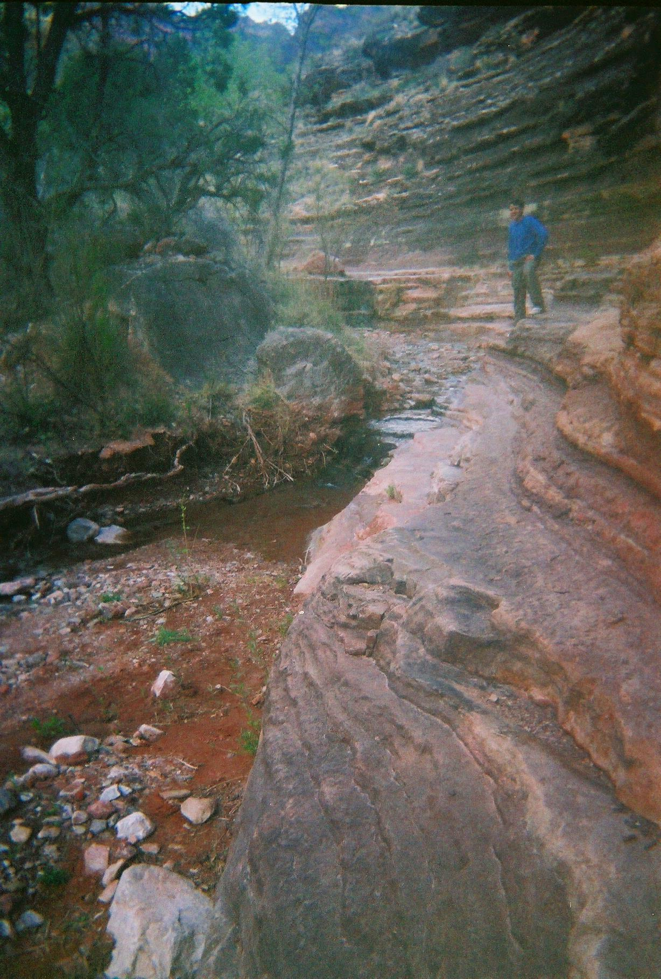
Cottonwood Creek

After we relaxed for awhile and re-charged our water supply for the rest of the day and night, we decided to hike upstream and to find the where the trail crossed and worked its way up toward the southern end of Horseshoe Mesa. On my April 2006 trek, I found this part of the trail to be extremely tricky as it crossed the creek a number of times and seemed to break off in various spurs toward campsites or other places. With Jordan this time, however, we learned that the trail is not as difficult to follow as I had before encountered. In 2006 I had taken the trail downward from the main trail, and it snaked in and through various campsites and crossed the creek a number of times before it basically ended. From that point, I had continued following the creek without a trail and luckily ended up at the point that where the main trail came from the west side of the creek and crossed over to where it led upward to the Mesa. This time, we did the same thing but noticed the trail on the west side much earlier and hooked up with it the rest of the way to where it crossed the creek that one last time. When we backtracked on that same trail and followed it all the way back to our campsite, we had no problem following it all the way to where it led downward to our spot. The trick seems to be to stay on the main trail. If I had not in 2006 taken the spur trail downward into the campsite areas and wound my way around the creek all the way to the trail crossing, staying on the main trail instead, I would have easily found the final trail crossing toward the Mesa.

The spot that Jordan and I discovered can easily mislead is where the southwestern arm of Cottonwood Creek joins the main draw. When on the main trail heading south, you will see that when that arm joins the main draw the trail crosses the creek about 20 yards or so east of where another spring seems to flow out of the southwestern arm. The trail breaks left and right, and it might be tempting to take the left leg of that trail since it seems to lead in the direction of the main creek. However, the leg that leads to the right side is the one to take, as it immediately stretches around a tree that hides a cairn. The trail then curls here and there and eventually ends up crossing the dry end of the main draw at its southern end as the trail heads up toward the Mesa. If the left leg is taken, it fades out quickly and becomes a number of undefined foot-paths that seem to lead nowhere. Following that section requires some route-finding confidence, and it is what I remember encountering in April 2006. You can eventually find the spot where the trail crosses by taking the left side, but it might be a little unsettling since the route is not clearly marked.

As we returned to our camp, the wind picked up considerably and we got a few raindrops. By the time we reached camp and rested awhile in our Tarptent Rainshadow II, the rain fell intermittently for about an hour. We experienced no real inclement weather the rest of the afternoon and night and slept pretty comfortably.

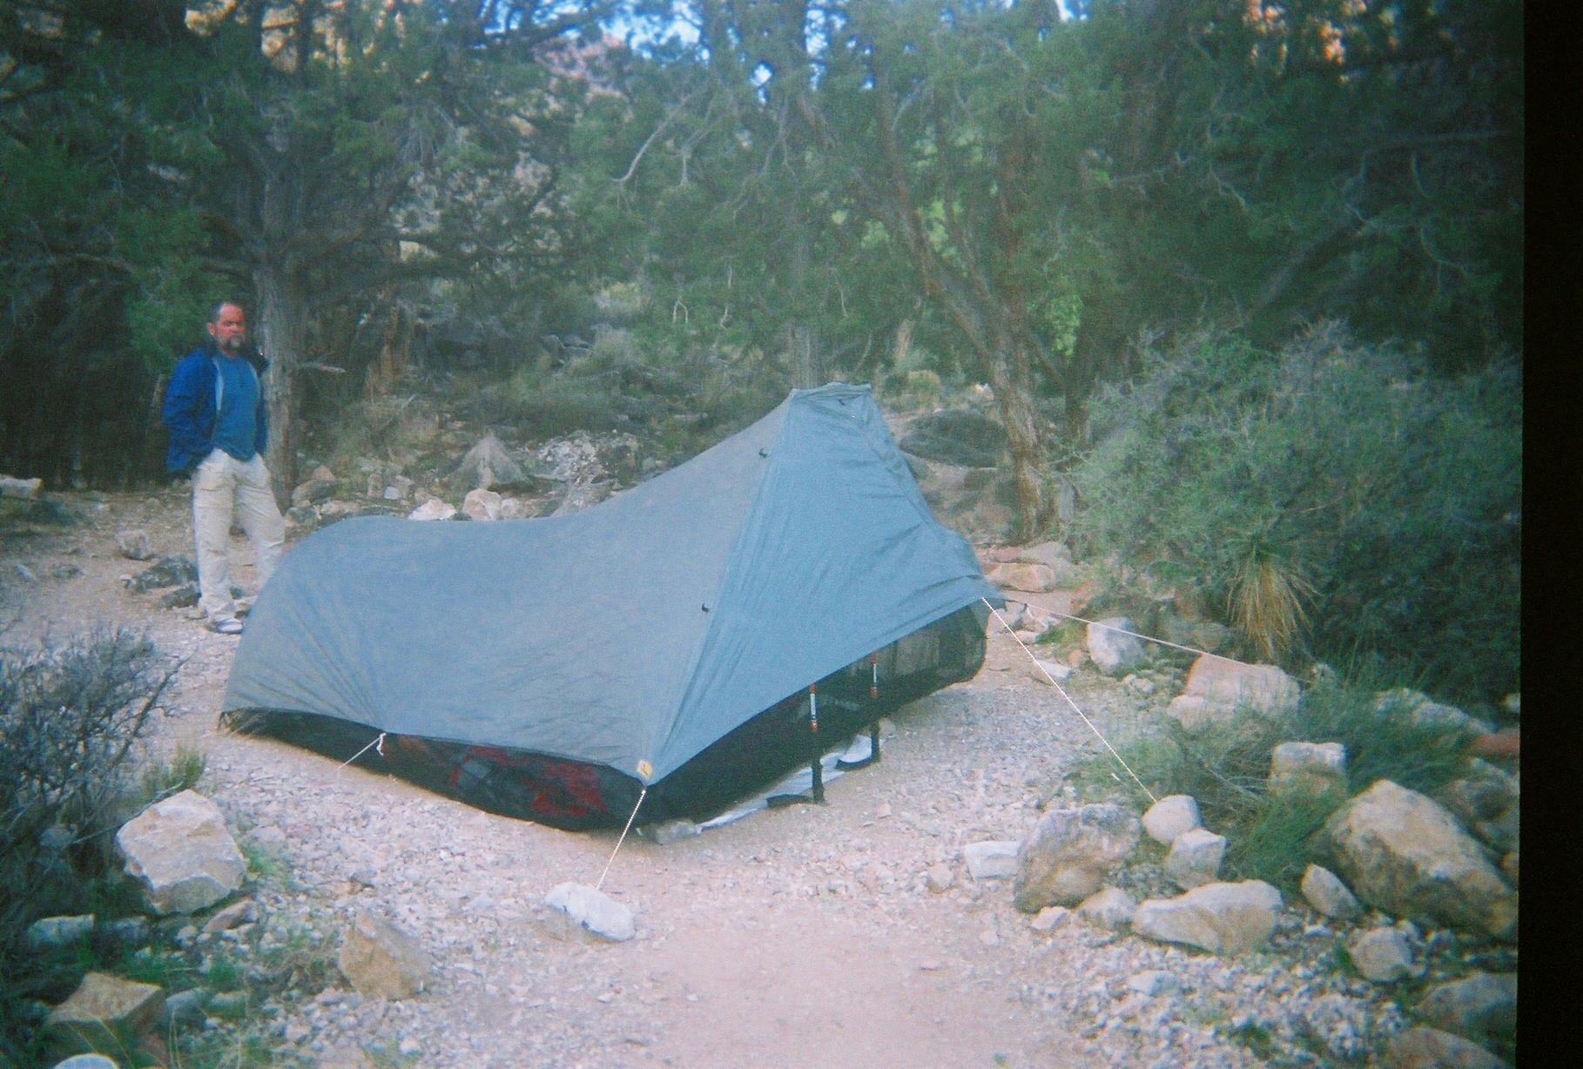
Cottonwood Creek Campsite

Day 5:

Our trek out of the Canyon began about 6:30 a.m. The skies were mostly cloudy, and the temperature started us out about 50 degrees. We had no difficulty finding our way out of Cottonwood Creek and up to the south side of the Mesa. The first 300 or 400 feet of ascent after the trail crosses the creek its final time is pretty loose and steep. Once the trail contours south there is a stretch of about ¼ mile that is fairly level and is a nice change before heading steeply up another ½ mile or so. We made good time and stopped for a couple of snack breaks.

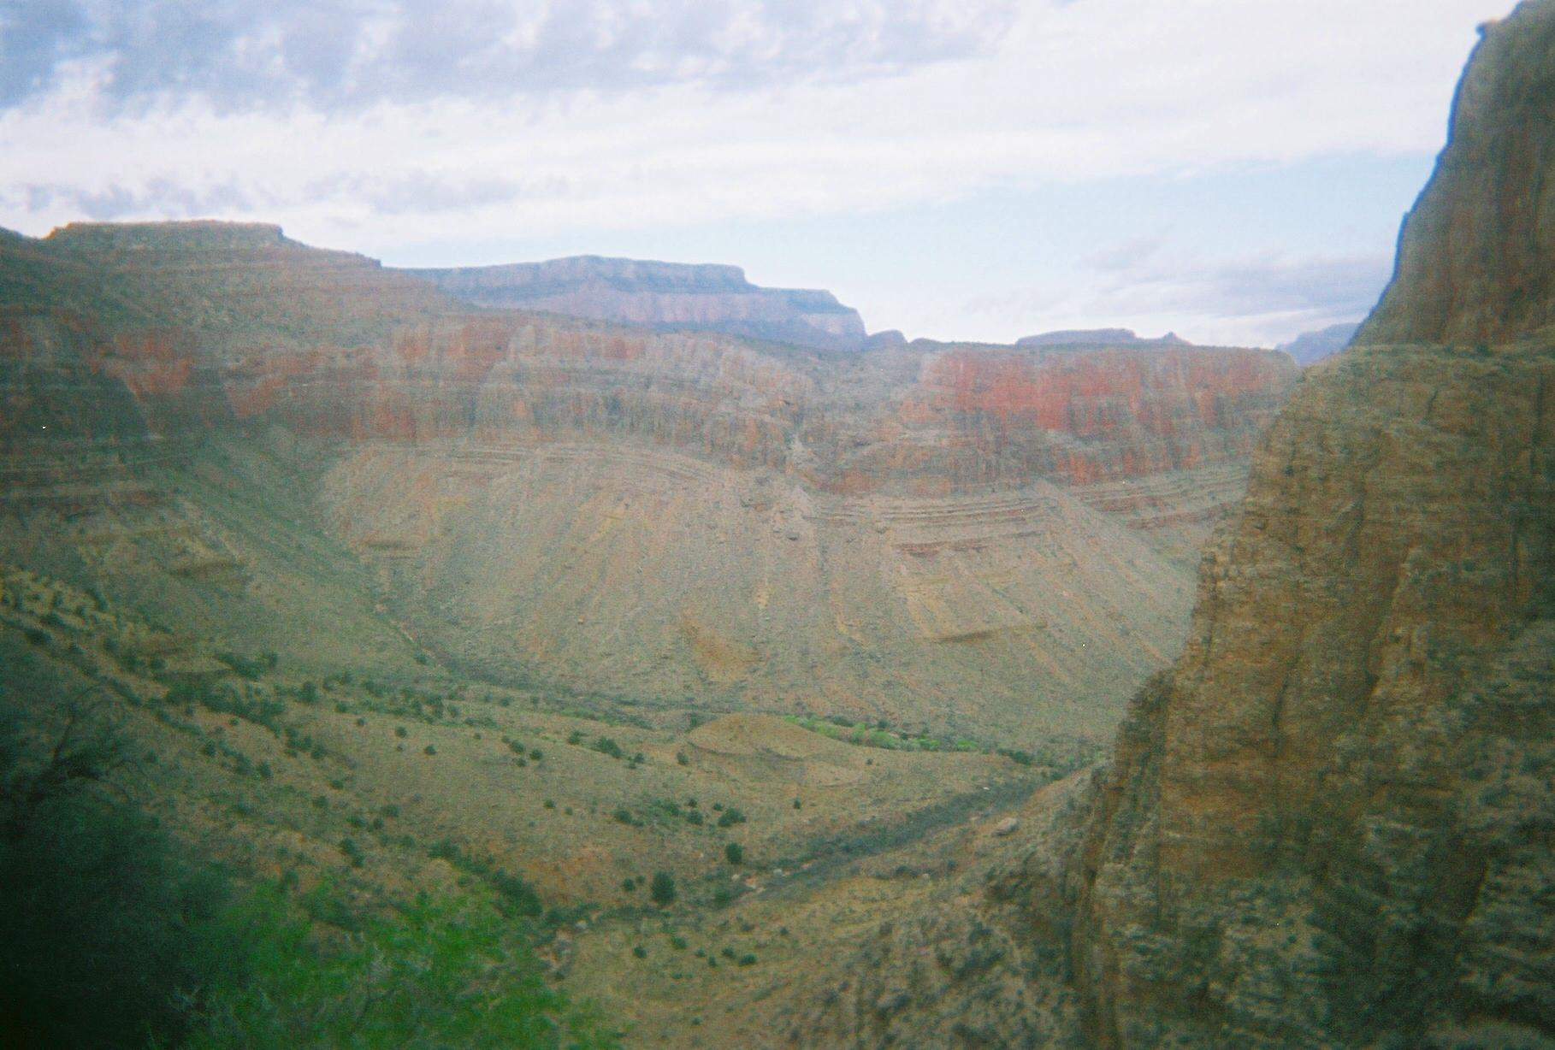
Looking northwest toward Cottonwood Creek on the way up to Horseshoe Mesa

Once we got to the neck of the Mesa we motored for about a mile along the Grandview Trail before we took another break. The temperatures warmed up to about 60 degrees, but it felt a little chillier because of the wind. This was the 4th time, I believe, that I had hiked up this trail, and each time I have remembered it being a challenge. There is a stretch of about ¼ to ½ mile after the first mile from the Mesa that it is basically level, but other than that it grades relentlessly uphill for about 2 and ¾ of its 3-mile hop. By the time the trailhead is reached, it seems a lot longer to me than 3 miles from the Mesa that is charted on the maps and Websites.

Overall, we had a pleasant though seemingly long climb out and reached the top bout 11:00 a.m. The wind was blowing pretty strongly, and the temperature had decreased to about 52 degrees. We hitched a ride from 3 rangers who were heading back toward the village; 2 of them had just returned from leading a group of trekkers back from Horseshoe Mesa, although we could not figure out what group they would have led. Jordan and I had tried for about 20 minutes to hitch a ride from various people heading out from the parking lot, but nobody to that point had been willing though 3 or 4 drivers had room. When I saw the rangers preparing to leave in their SUV, I asked them if they would be willing to give us a ride and they more than willingly obliged. I asked them if they had heard about the couple of day-hikers we encountered at Lonetree, and one of them replied that apparently the couple must have made it out of the Canyon in okay condition or all the rangers would have heard otherwise. They dropped us off at the Village Store where we had parked a few days earlier, and we rejoiced at another successful GC trek.

Summary:

Jordan and I had a lot of fun on this trek. I was especially glad that he found some great weather, for in our previous 2 trips in the Canyon together we were pounded with some heavy winds and precipitation. I found this trek to be a little easier going in 4 days than the in the 3 days I had completed it in April 2006. I would love to do it again sometime over about a 6- or 7-day period, taking a couple of layovers to explore and just hang out. We ran into 10 people during our trek, which is about 5 more than I saw in April 2006. The route has its challenging points, but they are off-set by the generally easy stretches along the Tonto Trail that simply wind around the long plateaus from canyon to canyon. I have done the trail 2 times now and was blessed with really nice weather both times. I encourage anyone who does it from west to east be prepared for a long day into Lonetree Canyon; after that day the lengths from place to place seem minor. Of course, the hiking distances depend on how the trip is planned, so it is possible to enter this route from either side and go a shorter distance the first day. One could take the route I have described twice now and plan the first day’s stop just inside the Cremation Canyon usage area, which is only about 6-7 miles down from the South Kaibab Trailhead. Generally there is no water in that area, though, which is why I like to push all the way to Lonetree. However, Lonetree Creek is apparently not a perennial water source either, so you might need to carry at least 2 days of water to reach Grapevine from the South Kaibab side. I have been fortunate that water was readily available at Lonetree both times I have done the route. It is important to check with the Backcountry Office about this trek to get updates on trail conditions and water availability. I have found the rangers to be more than happy to answer questions and provide their secrets to handling the trails successfully.

